Group Id : A6

Project Name : Stock Candle

Group Members :

Utkarsha Abhang

Piyush Adhalikar

Atharva Mulay

Anushka Mulay

Diagrams :

Use case diagram

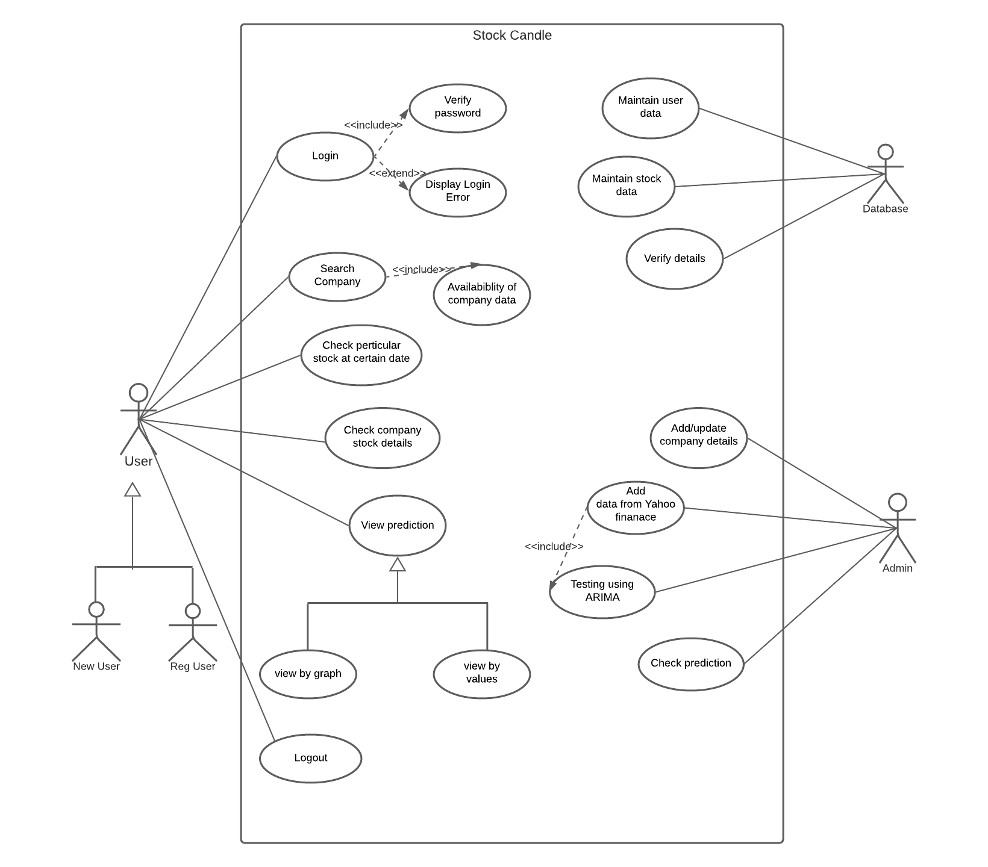

Activity diagram

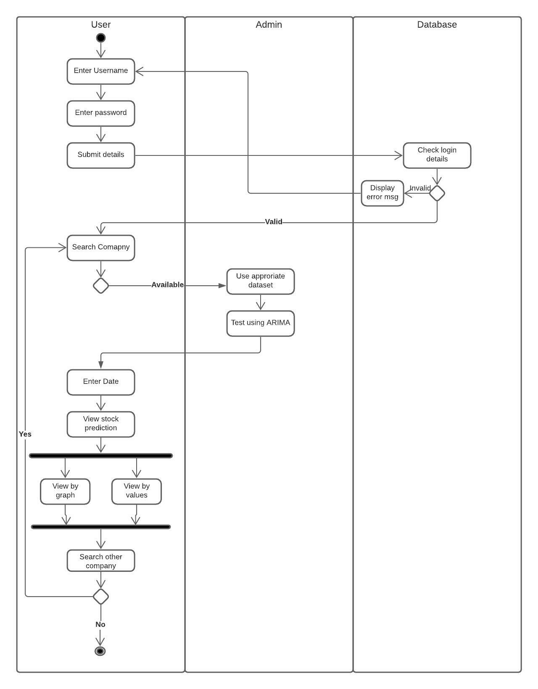

Sequence diagram

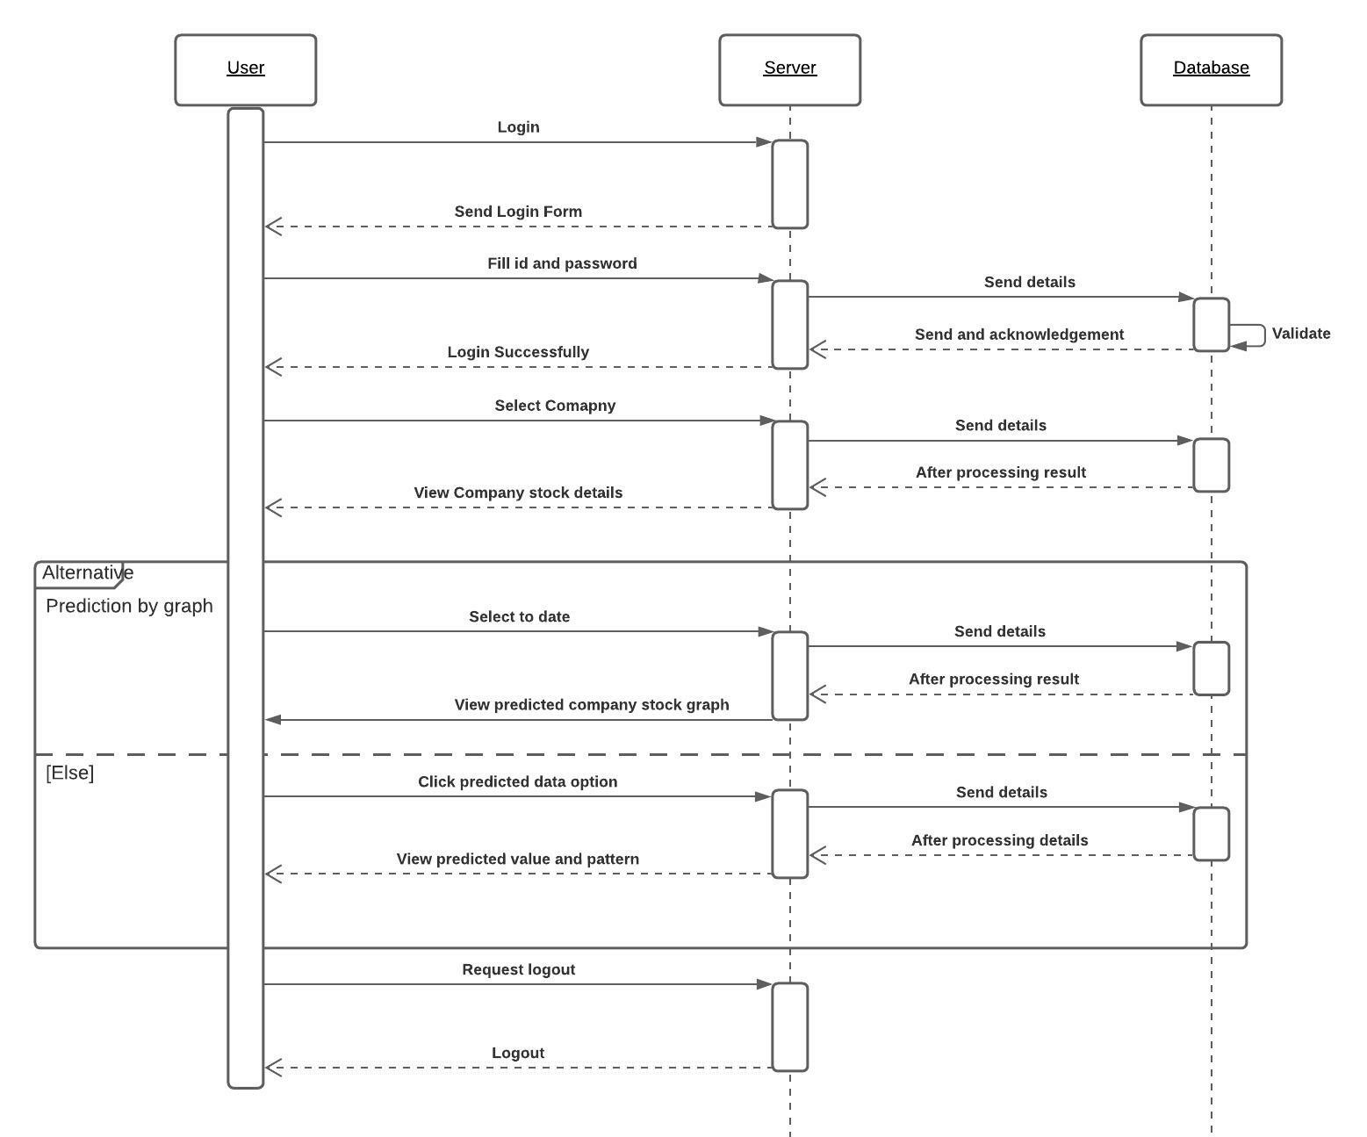

Block diagram

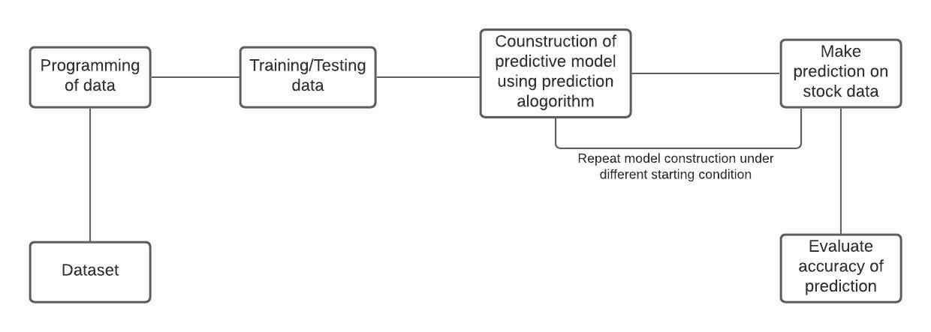

Class diagram

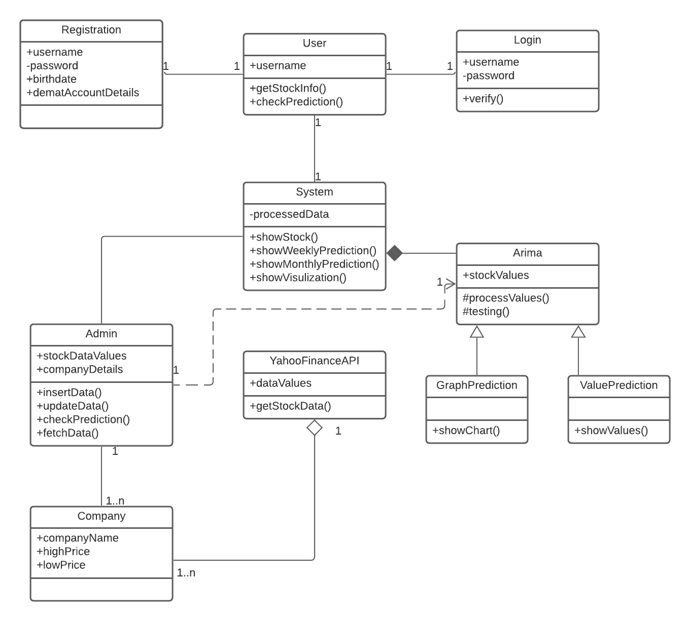

State diagram

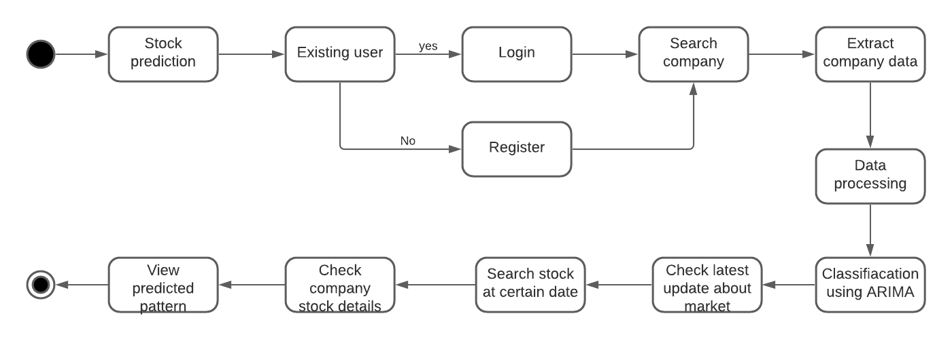

DFD diagram

